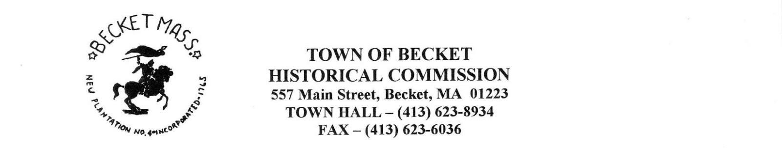
Meeting Date: Tuesday, July 11, 2023
Meeting Time: 5:00 PM
Meeting Place: Becket Community Room, Becket Town Hall
Attendees: Sandi Jarvis, Rita Furlong, Gail Kusek, Michael Lavery, John Garvey
Minutes
- The meeting was called to order at 5:00pm by Chair Sandi Jarvis
- Clerk’s Minutes: A motion was made by RF to approve the minutes from the June 2023 meeting with the correction of the word “Agenda” to “Minutes” in the header. Seconded by GK, passed unanimously.
- Treasurer’s Report: RF reports there is an outstanding invoice for the printer at $624.59, when this is processed the commission balance will be $434.87. There is also $656.40 in the Donations and Gifts Account. RF will request the carryover of all unspent funds into the next fiscal year.
- Communications
  - New-
    - Town notifications: None requiring action.
    - Michael Babcock re: Babcock/Marcy, Meach ancestors. SJ has sent information concerning these Western Reserve (Ohio) families, this triggered another Western Reserve query that SJ will research.
    - Query from Megan Smith re: School contact information. No action required.
    - Query from Smith Amanda re: updating B2B Marketing database with Recreational Facilities information. No action required.
    - Goodhind envelope/package for John: Return of lent thumb drive.
    - Lydia Rosner has scanned many Becket postcards and provided us with a thumb drive containing them. She has requested a donation letter from the Commission for the costs associated with the scanning. JG will follow-up.
  - Old
    - Follow-up Mama Frasca 45 rpm record, Dream Away Berkshire Magazine article: SJ has requested a digital and hard copy of the magazine article.

    - Follow-up Marty Drennan re: Stephens and Meach ancestors: SJ remains in communication on these queries.
    - Follow-up Becket Athenaeum Executive Director, Jodi Shafiroff re: local history programs: SJ will communicate with Jodi.
- New Business
  - Revolutionary War veterans-GK has been researching Revolutionary War and Civil War veterans and has found some names that are not on our plaque. She will continue her research.
  - RF reports that Katherine Houk has done more office work for the Commission, the Commission thanks her for her continued support.
- Old Business
  - Member appointments BOS June 21, re: Michael Lavery, Rita
  - Cupola restoration: JG and RF report that the initial meetings with the architect, engineer and contractor have occurred, everyone is on the same page. The engineer (John Wallen) visited the town hall on July 10 to take measurements in the attic to come up any necessary structural updates. The architect (Jeff Penn) will work up drawings of the cupola for our approval and submission to the Select Board.
  - Ballou Park signage-Native American mill stone: GK will work on wording for an interpretive sign.
  - Office color printer/copier/scanner: This has arrived but is not yet set up for use.
  - Historic Building Plaques: JG reports that he has contacted the vendor being used by the Lenox Historical Commission and is awaiting a reply. The previous authorization for JG to purchase one sign at less than $75 is still active from the last meeting.
  - Massachusetts State Archive maps: JG reports no progress.
- A motion was made to adjourn the meeting at 5:56pm by RF, seconded by ML. Passed unanimously.
Minutes submitted by John Garvey, Clerk.
Next meeting – Aug 8 at 5:00 PM, Becket Town Hall

